**Introduction:**

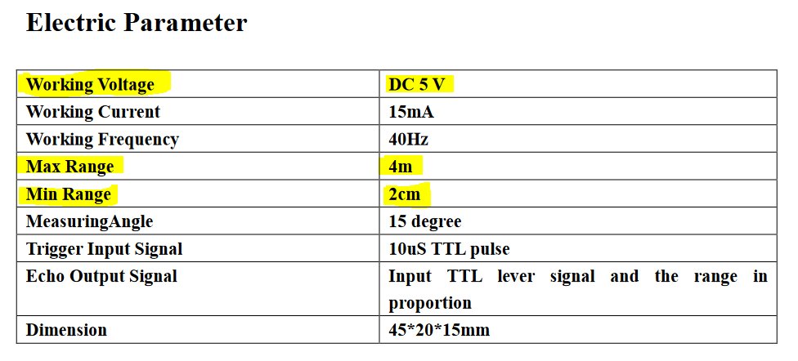

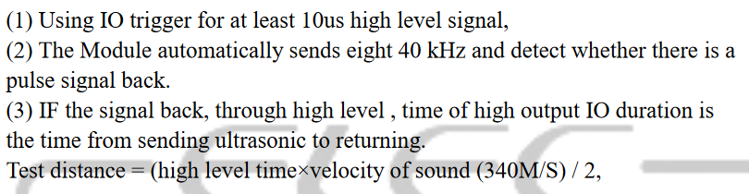

For example, if the object is 10 cm away from the sensor, and the speed of the sound is 340 m/s or 0.034 cm/µs the sound wave will need to travel about 294 µs. But what you will get from the Echo pin will be double that number because the sound wave needs to travel forward and bounce backward. So, to get the distance in cm we need to multiply the received travel time value from the Echo pin by 0.034 and divide it by 2.

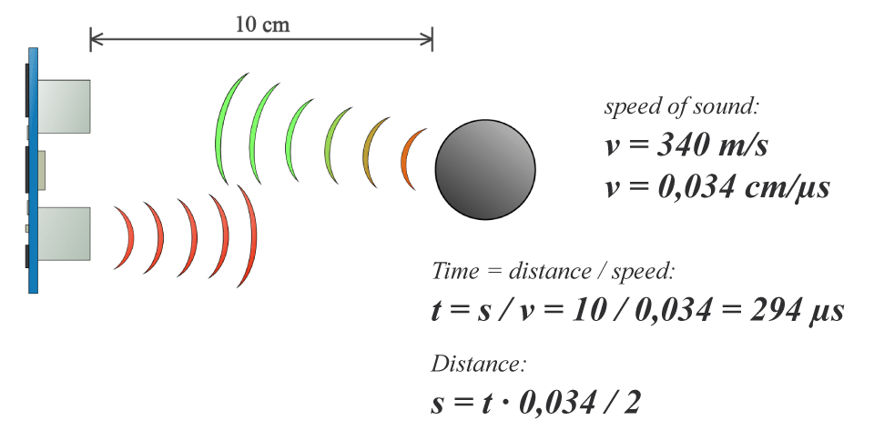

**Constraints:**

* Max Range = 4m, which means Max Time = 11.765 ms or Max **Echo** Duration = 23.53 ms. The default timeout duration is 38 ms (when there is no obstacle), which is why the recommended cycle period is at least 50 ms. We should use 60 ms cycle period for redundancy.
* Trigger pin needs to be HIGH for at least 10 µs.

**Example Arduino C code:**

// defines variables

long duration;

int distance;

void loop() {

// Clears the Trigger pin

digitalWrite(trigPin, LOW);

delayMicroseconds(2);

// Sets the Trigger pin on HIGH state for 10 microseconds

digitalWrite(trigPin, HIGH);

delayMicroseconds(10);

digitalWrite(trigPin, LOW);

// Reads the Echo pin, returns the sound wave travel time in microseconds

duration = pulseIn(echoPin, HIGH);

// Calculating the distance

Distance = duration*0.034/2;

// Prints the distance on the Serial Monitor

Serial.print("Distance: ");

Serial.println(distance);

}

**VHDL:**

* 1 input port for Echo pin, 1 output port for Trigger pin.
* 1 input port called PullMode (continuously run).
* 1 output vector port for the actual duration after calculation (TBD).
* Trigger the sensors every 60 ms or whenever the processor issues a command (TBD).